

**KIET Group of Institutions, Ghaziabad**

**COMPUTER SCIENCE AND INFORMATION TECHNOLOGY**

**PROJECT BASED LEARNING**

**on**

**ROCK PAPER SCISSOR GAME**

**SUBJECT: DSUC LAB**

**Submitted By:**

**AANYA GOEL - 210090110002 (CSIT 3A)**

**DISHANT SHARMA- 2100290110053(CSIT 3A)**

**ACKNOWLEDGEMENT**

## I’ve got this golden opportunity to express my kind gratitude and sincere thanks to my subject faculty **“Mr. Vinay Kumar”**, Computer Science and Information Technology Department, **KIET GROUP OF INSTITUTIONS** for their kind support and necessary counselling in the preparation of this project report. I’m also indebted to each and every person responsible for the making up of this project directly or indirectly.

I must also acknowledge or deep debt of gratitude each one of my colleague who led this project come out in the way it is. It’s my hard work and untiring sincere efforts and mutual cooperation to bring out the project work. Last but not the least, I would like to thank my parents for their sound counselling and cheerful support. They have always inspired us and kept our spirit up.

**ABSTRACT**

The main objective of the rock-paper-scissor project is to build a game for a single player that plays with a computer, anywhere, and anytime. In this project, players have to choose any one from rock, paper, and scissors. Then click on the play button will show the result of the game. This project is base on the rules that:

* rock blunts scissors so rock wins
* scissors cut the paper so scissors win
* paper cover rock so paper wins

It is a zero-sum game, it has three possible outcomes: a draw, a win or a loss. A player who decides to play rock will beat another player who has chosen scissors ("rock crushes scissors" or "breaks scissors" or sometimes "blunts scissors"), but will lose to one who has played paper ("paper covers rock"); a play of paper will lose to a play of scissors ("scissors cuts paper"). If both players choose the same shape, the game is tied and is usually immediately replayed to break the tie. The game spread from China while developing different variants in signs over time.

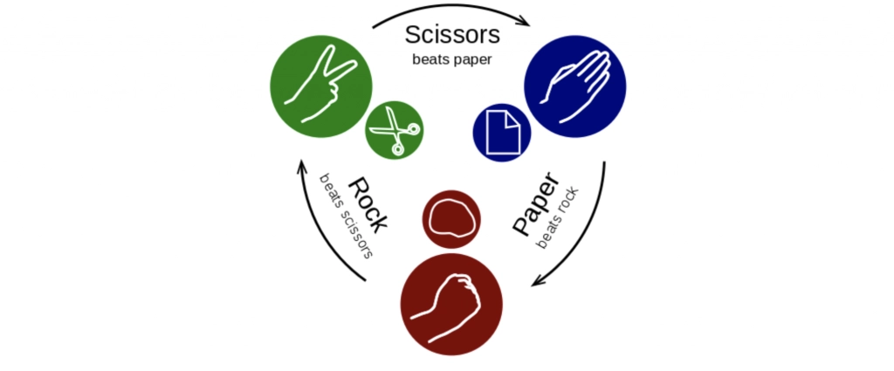

**INDEX**

1. Introduction

2. Requirement Analysis

3. Design ( Define Design Methodology based on your Problem Statement )

4.Coding and Implementation (Algorithm and Program )

5.Result /Output ( Discuss the Time and Space Complexity using Recurrence )

6.Reference

**INTRODUCTION**

Rock paper scissors is often used as a fair choosing method between two people, similar to coin flipping, drawing straws, or throwing dice in order to settle a dispute or make an unbiased group decision. Unlike truly random selection methods, however, rock paper scissors can be played with a degree of skill by recognizing and exploiting non-random behavior in opponents.

Problem states that playing the game for tossing for something or to relax the mind when stressed by playing something that can be easy to access and efficiently.

Rock-paper-scissors (RPS for short) game widely used to**study competitive phenomena in society and biology**, especially species diversity and pattern formation, offers a new way.

**REQUIREMENT ANALYSIS**

1. For performing our task we require different online c compilers to run the task and check the implementation of the code we wanted to apply in making the game.
2. Hardware we used is dell’s laptop with all the features present in it and inbuilt software for implementing the code and get the desired outcome as output.
3. We can also implement the code on visual studio code on different computer and features which can run the c code.
4. With the help of strings and function this project is made.
5. In the real game of rock paper scissor, the rock dominates over the scissor, scissor dominates over the paper and paper dominates over the rock.The game can be modelled using a directed graph as below, in which the directed **edge (a, b)** shows that **a** dominates over **b**

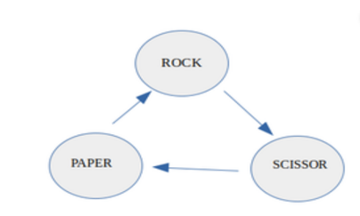

**DESIGN**

Main function():

It consist of declaration of variables.

Printf() and scanf() functions for diaplaying the contemt and taking inpug from the user. It also contains two predefined functions:

Srand() and rand() for generating radom numbers in the range[0, rand_max) and srand() to generate number at each time.

Modulo will be in between 0 and 100.

In this range only the stone paper scissor number will lie and probability will be calculated on ther basis of that.

Game() function consist of if else statements to compare user and computer choices and accordingly points will be awarded.

# CODING IMPLEMENTATION:

# 

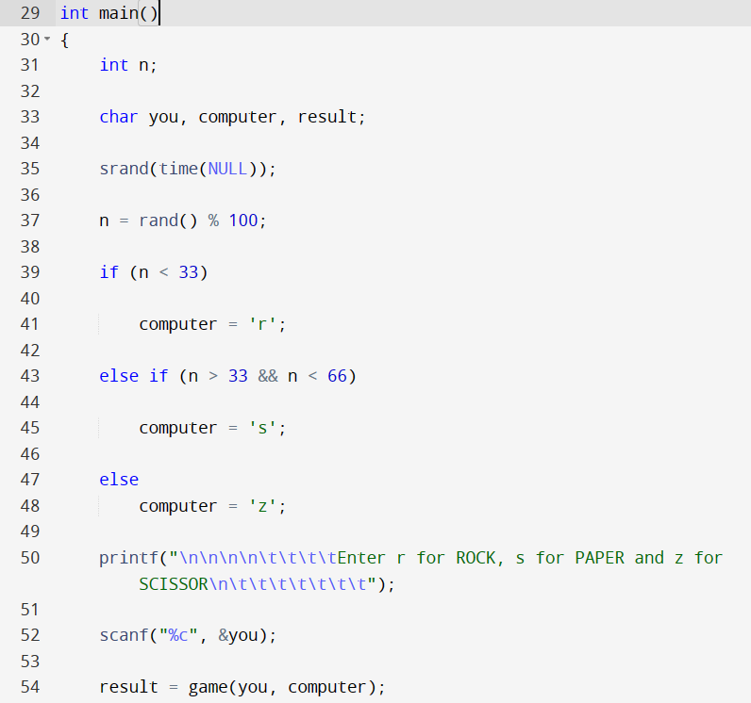

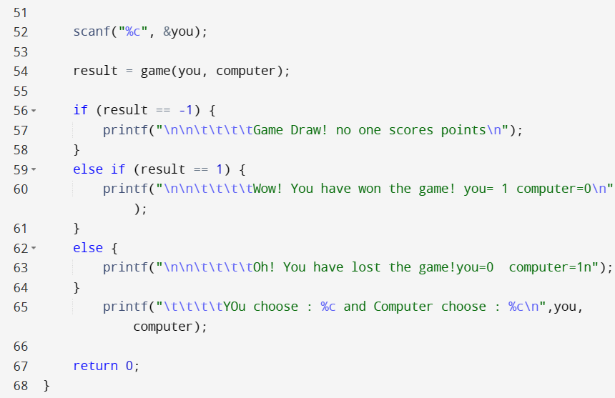

**OUTPUT SCREENSHOT**

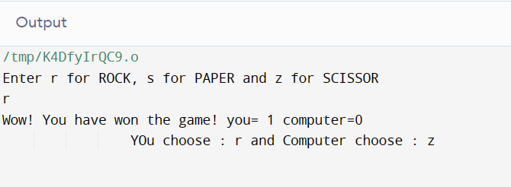

# RESULT/OUTPUT

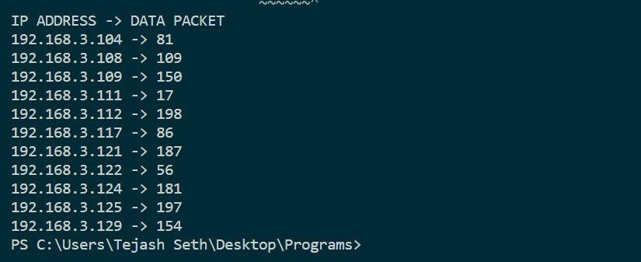

**TIME COMPLEXITY:** O(logn)

# SPACE COMPLEXITY: O(1)

**REFERENCE:**

1. [https://www.youtube.com/watch?v=qMmqOHr75b8&ab_channel=Jenn](https://www.youtube.com/watch?v=qMmqOHr75b8&ab_channel=Jenny%27slecturesCS%2FITNET%26JRF) [y%27slecturesCS%2FITNET%26JRF](https://www.youtube.com/watch?v=qMmqOHr75b8&ab_channel=Jenny%27slecturesCS%2FITNET%26JRF)
2. [https://www.youtube.com/watch?v=1HeIZNP3w4A&ab_channel=Jenny](https://www.youtube.com/watch?v=1HeIZNP3w4A&ab_channel=Jenny%27slecturesCS%2FITNET%26JRF)

## [%27slecturesCS%2FITNET%26JRF](https://www.youtube.com/watch?v=1HeIZNP3w4A&ab_channel=Jenny%27slecturesCS%2FITNET%26JRF)